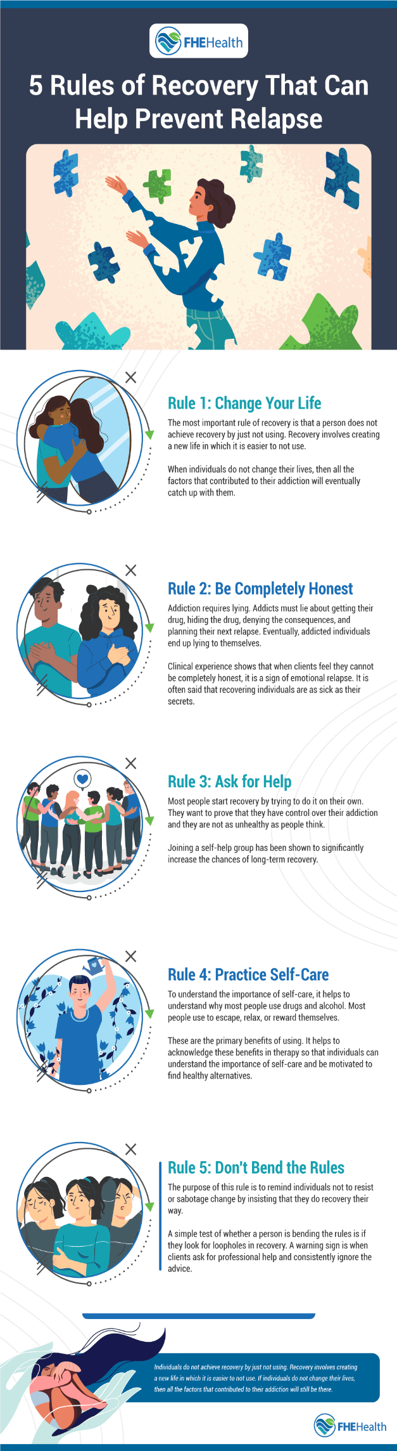
1. Change Your Life
Stopping alcohol or drug use isn’t enough to recover fully from an addiction. Long-term recovery requires you to change your lifestyle by eliminating unhealthy habits and avoiding situations that trigger your drinking or drug use. Here are a few coping methods to help you during your recovery.
Seek Family Therapy
Even if your family members don’t drink or use drugs, you may need to overcome some dysfunctional family dynamics to stay on the road to recovery. For example, one of your parents may engage in enabling behavior by loaning you money or allowing you to use drugs or alcohol in their home. Family therapy addresses these dysfunctional dynamics, helping you form positive relationships with siblings, parents, children and other loved ones.
Find New Hobbies
If your favorite activities are associated with drinking or other types of substance use, it’s time to find new hobbies. Gambling is a good example. It’s possible to gamble without drinking, but many casinos offer free drinks to entice patrons to gamble for hours on end. Putting yourself in this environment makes it more difficult to stay sober. If necessary, find new hobbies that don’t involve alcohol or drugs.
Choose a New Job
Some jobs are associated with high levels of substance use, particularly in high-pressure fields. For example, people who work long hours in banking and finance may turn to stimulants to keep themselves awake and productive.
You may also be tempted to use alcohol if your current job involves “wining and dining” clients to close big deals. If you have a high-stress job or a job that regularly puts you into contact with people who are drinking or using drugs, switching careers can help you prevent a relapse.
Form New Friendships
To reduce your risk of relapse, it’s also important to form new friendships with people who won’t do anything to jeopardize your recovery. This includes using substances in your presence or encouraging you to use substances. Therefore, you may need to form new friendships and stop spending time with people who sell drugs or have frequent parties.
Clear Out the Clutter
Avoiding temptation is easier if you get rid of all the substance-related items in your home. Shot glasses, beer steins, rolling papers, needles and other items have no place in the home of someone who’s trying to avoid relapse.
2. Be Completely Honest
When addiction has a hold on you, lying becomes second nature. You may lie about how often you’re using, what you’re using, where you got the money to buy drugs or alcohol or who you’re spending time with. If your addiction stems from childhood trauma, you may also be skilled at pushing the trauma down instead of talking it through. Honesty is an important aspect of any relapse prevention plan, as it allows you to form positive relationships with other people in recovery.
3. Ask for Help
Not asking for help is one behavior associated with an emotional relapse. Even if you’re not using, refusing to ask for help shows that you’re likely to relapse in the near future. If you’re not already participating in a support group, take time to find one in your neighborhood. Alcoholics Anonymous and Narcotics Anonymous both have online tools to help you find local meetings.
4. Practice Self-Care
Caring for yourself can make the difference between continued recovery and relapse. Eating nutrient-rich foods, drinking plenty of water and getting enough sleep each night are good ways to avoid hunger and fatigue, two factors that sometimes contribute to substance abuse. You should also consider meditating, doing yoga or participating in another activity that reduces stress and strengthens the mind-body connection.
5. Don’t Bend the Rules
If you have a relapse prevention plan in place, you need to commit to it fully. Instead of bending the rules or trying to find loopholes, embrace your recovery and dedicate yourself to following the rules. Your way didn’t work in the past, so now is the time to follow your therapist’s advice and stay on their recommended path to recovery.
V.I.A

The Five Rules

How will I change my life?

How do I practice being completely honest?

How do I ask for help?

How do I practice self-care – physical & emotional?

Do I break the rules?

